

**CSE 311L(Database Management System)**

**LAB-Week 4**

***Topics:

Basic SELECT Statement

Selecting All Columns, Specific Columns

Arithmetic Expressions, Using Arithmetic Operators, Parenthesis Defining a Column Alias

# *BASIC QUERIES IN SQL

* SQL has one basic statement for retrieving information from a database; the SELECT statement
* This is *not the same as* the SELECT operation of the relational algebra
* Important distinction between SQL and the formal relational model;
* SQL allows a table (relation) to have two or more tuples that are identical in all their attribute values.
* Hence, an SQL relation (table) is a *multi-set* (sometimes called a bag) of tuples; it is *not* a set of tuples.
* SQL relations can be constrained to be sets by using the CREATE UNIQUE INDEX command, or by using the DISTINCT option
* Basic form of the SQL SELECT statement is called a *mapping* of a *SELECT-FROM- WHERE block*

SELECT <attribute list> FROM <table list> WHERE <condition>

* <attribute list> is a list of attribute names whose values are to be retrieved by the query
* <table list > is a list of the relation names required to process the query
* <condition> is a conditional (Boolean) expression that identifies the tuples to be retrieved by the query

# Basic SELECT Statement

SELECT *|{[DISTINCT] *column*|*expression* [*alias*],...}

FROM *table;*

# Arithmetic Operators

SELECT last_name, salary, 12*(salary+100) FROM emps;

# Using Column Aliases

SELECT last_name "Name", salary*12 "Annual Salary" FROM emps;

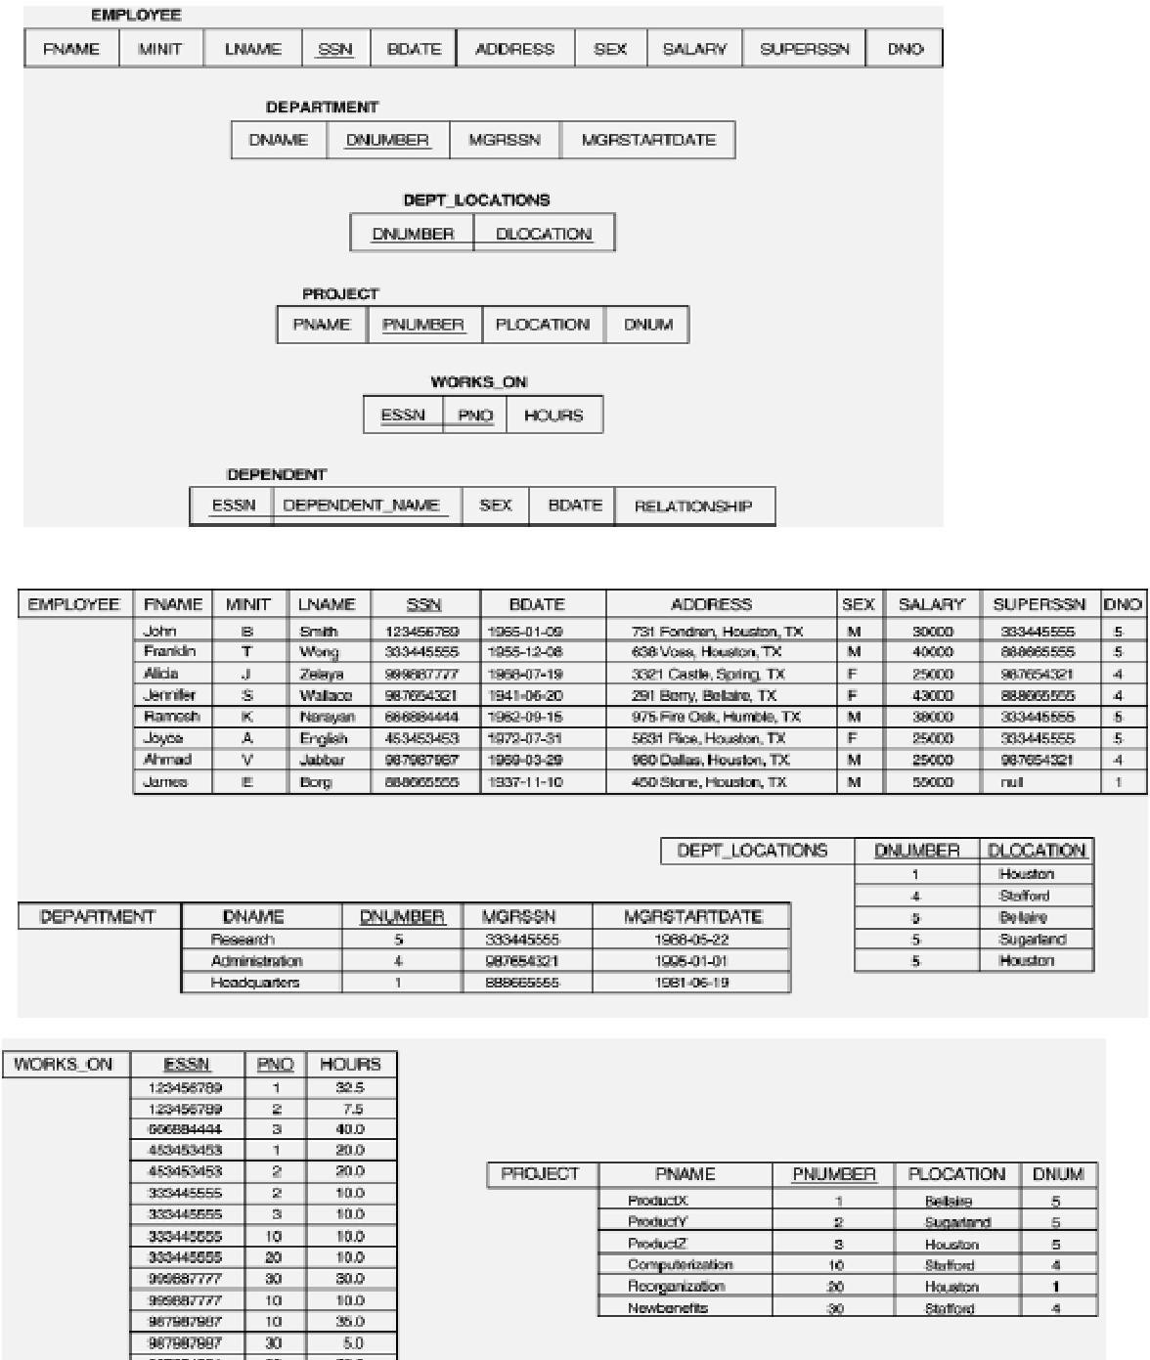Run: Populate the table with data given and running company,sql in the mysql promt All subsequent examples uses COMPANY database as shown below:

# Example of a simple query on one relation

**Activity - 01: Retrieve the birth date and address of the employee whose name is 'John Smith'.**

SELECT BDATE, ADDRESS FROM EMPLOYEE

WHERE FNAME='John' AND LNAME = 'Smith‘

The SELECT-clause specifies the projection attributes and the WHERE-clause specifies the selection condition. However, the result of the query may contain duplicate tuples

# Example of a simple query on two relations

**Activity - 02: Retrieve the name and address of all employees who work for the 'Research' department.**

SELECT FNAME, LNAME, ADDRESS FROM EMPLOYEE, DEPARTMENT

WHERE DNAME = 'Research' AND DNUMBER = DNO

Similar to a SELECT-PROJECT-JOIN sequence of relational algebra operations (DNAME='Research') is a selection condition (corresponds to a SELECT operation in relational algebra) (DNUMBER=DNO) is a join condition (corresponds to a JOIN operation in relational algebra).

# Example of a simple query on three relations

**Activity - 03: For every project located in 'Stafford', list the project number, the controlling department number, and the department manager's last name, address, and birth date.**

SELECT PNUMBER, DNUM, LNAME, BDATE, ADDRESS FROM PROJECT, DEPARTMENT, EMPLOYEE

WHERE DNUM=DNUMBER AND MGRSSN=SSN AND PLOCATION='Stafford'

There are two join conditions. The join condition DNUM=DNUMBER relates a project to its controlling department. The join condition MGRSSN=SSN relates the controlling department to the employee who manages that department.

# ALIASES, * AND DISTINCT, EMPTY WHERE-CLAUSE

* In SQL, we can use the same name for two (or more) attributes as long as the attributes are in different relations
* A query that refers to two or more attributes with the same name must qualify the attribute name with the relation name by prefixing the relation name to the attribute name. **Example:** EMPLOYEE.LNAME, DEPARTMENT.DNAME
* Some queries need to refer to the same relation twice. In this case, aliases are given to the relation name

# Example

**Activity - 04: For each employee, retrieve the employee's name, and the name of his or her immediate supervisor.**

SELECT E.FNAME, E.LNAME, S.FNAME, S.LNAME FROM EMPLOYEE E, EMPLOYEE S

WHERE E.SUPERSSN = S.SSN

The alternate relation names E and S are called aliases or tuple variables for the EMPLOYEE relation We can think of E and S as two different copies of EMPLOYEE; E represents employees in role of supervisees and S represents employees in role of supervisors

Aliasing can also be used in any SQL query for convenience. Can also use the AS keyword to specify aliases

SELECT E.FNAME, E.LNAME, S.FNAME, S.LNAME FROM EMPLOYEE AS E, EMPLOYEE AS S

WHERE E.SUPERSSN = S.SSN

# UNSPECIFIED WHERE-clause

A missing WHERE-clause indicates no condition; hence, all tuples of the relations in the FROM-clause are selected. This is equivalent to the condition WHERE TRUE

Example:

# Activity - 05 Retrieve the SSN values for all employees.

SELECT SSN FROM EMPLOYEE

If more than one relation is specified in the FROM-clause and there is no join condition, then the CARTESIAN PRODUCT of tuples is selected.

Example:

SELECT SSN, DNAME

FROM EMPLOYEE, DEPARTMENT

**Note:** It is extremely important not to overlook specifying any selection and join conditions in

the WHERE-clause; otherwise, incorrect and very large relations may result.

# USE OF *

To retrieve all the attribute values of the selected tuples, a * is used, which stands for all the attributes

Examples:

# Activity – 06: Retrieve all the attribute values of EMPLOYEES who work in department 5.

SELECT *

FROM EMPLOYEE WHERE DNO = 5

# Activity – 07: Retrieve all the attributes of an employee and attributes of DEPARTMENT he works in for every employee of ‘Research’ department.

SELECT *

FROM EMPLOYEE, DEPARTMENT

WHERE DNAME='Research' AND DNO=DNUMBER

Find the results in SQL for these queries:

1. Find the first name and Last name of the employees who are supervised by “Franklin Wong’?

→ **SELECT E.LNAME, E.FNAME**

**FROM employee E, employee S**

**WHERE S.FNAME='Franklin' AND S.LNAME='Wong' AND E.SUPERSSN=S.SSN;**

1. Find the last and first name of the female employees who have a dependent with the same first name as themselves?

→

1. Retrieve all employees whose address is in Houston, Texas.
2. Find all employees who were born during the 1960s.
3. Increase the salary of all employees working on the 'ProductX' project by 10%.
4. Find the sum of the salaries of all employees, the maximum salary, the minimum salary, and the average salary. Display with proper headings.